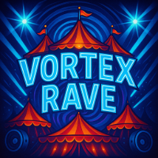

Costume Sections & Prices:
BacchaX – US$160
Installment: US$38.67/month
Inclusive Fee: US$50 (partial) / US$150 (full)
Xod-Us – US$220
Installment: US$73.33/month
Inclusive Fee: US$50 (partial) / US$150 (full)
JamCarm X – US$280
Installment: US$116.70/month
Inclusive Fee: US$50 (partial) / US$150 (full)

Fant-X – US$350
Installment: US$141.70/month
Inclusive Fee: US$50 (partial) / US$150 (full)
DreamX – US$425
Installment: US$141.70/month
Inclusive Fee: US$50 (partial) / US$150 (full)

Vortex Rave
“JOIN THE VIBE. LIVE THE VIBE. BE THE VIBE.”

Contact Us:
Email: vortexravecarnival@gmail.com

Call/WhatsApp: +1 (876) 555-1234

Instagram: @vortexrave

Website: www.vortexravecarnival.com

